Final Project

**A Broken Game**

Made on unreal engine 5, A Broken Game is a 2D platformer where you play as an unfinished sprite with very limited movement. As you explore the 2D terrain, you find surprising potholes and unexpected “fractures” that traps you in a place of no return.

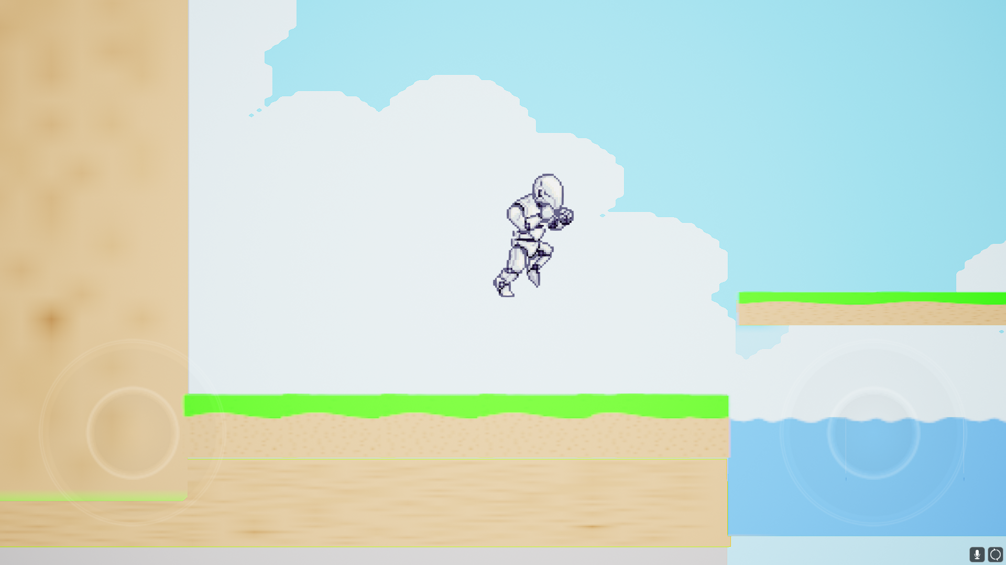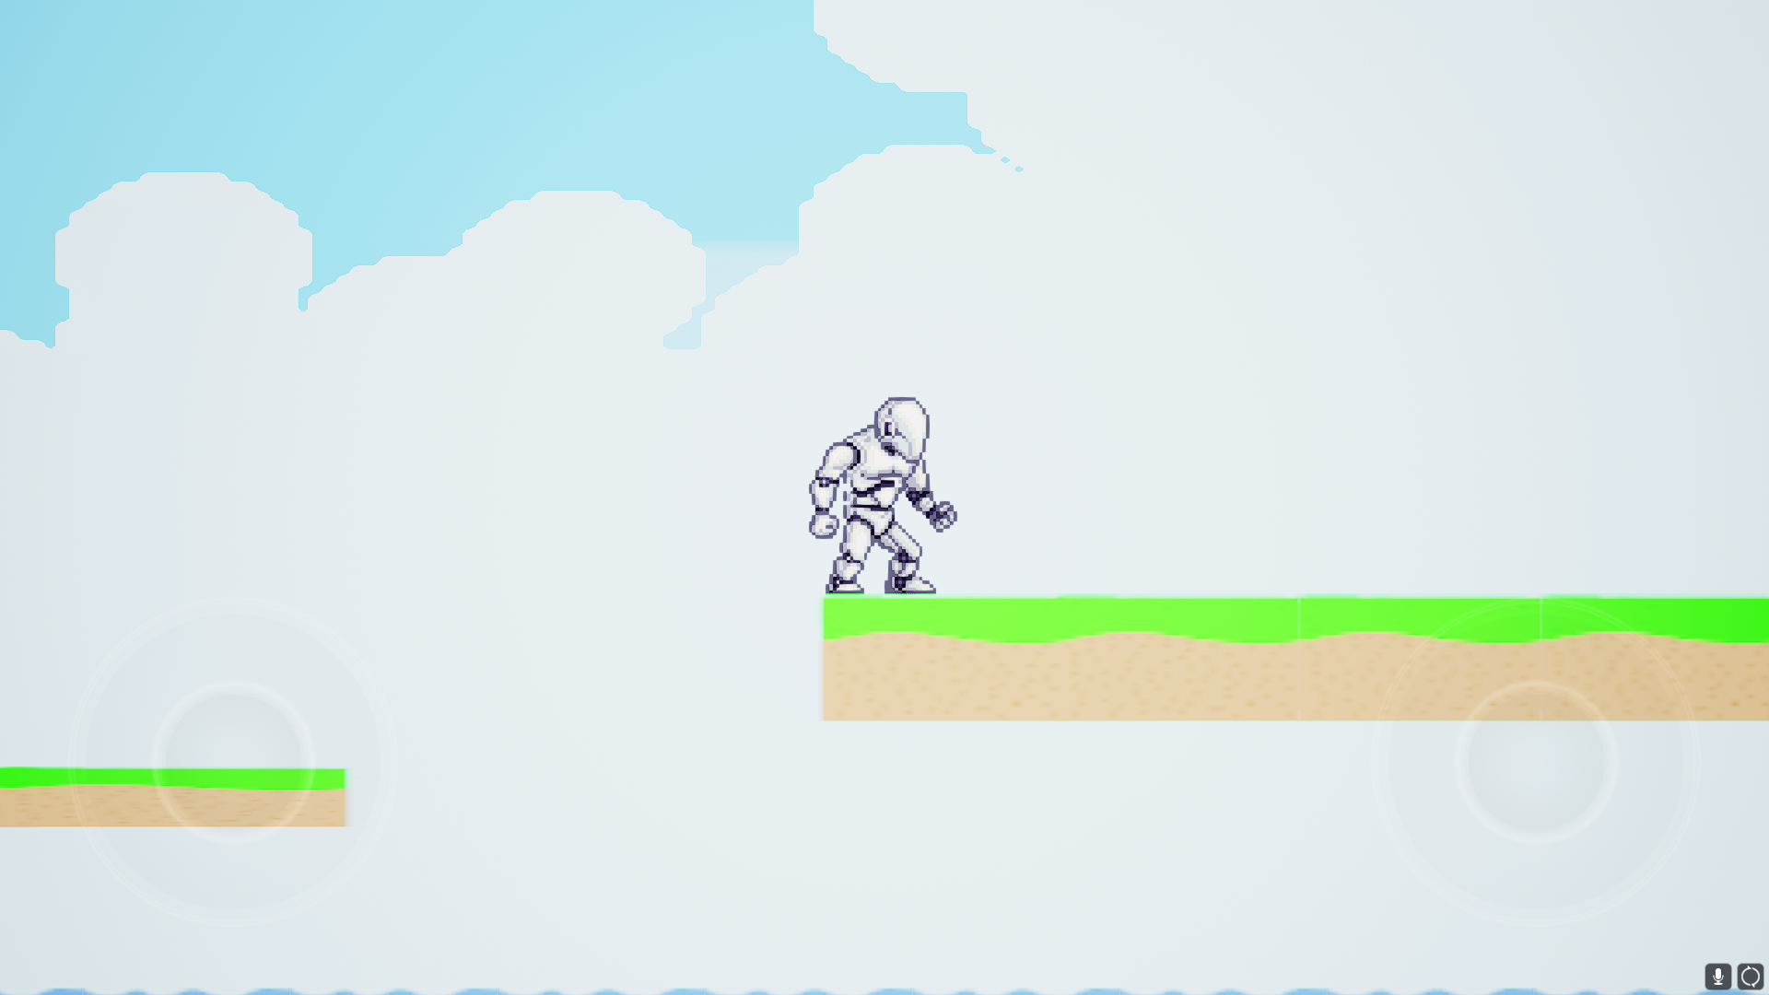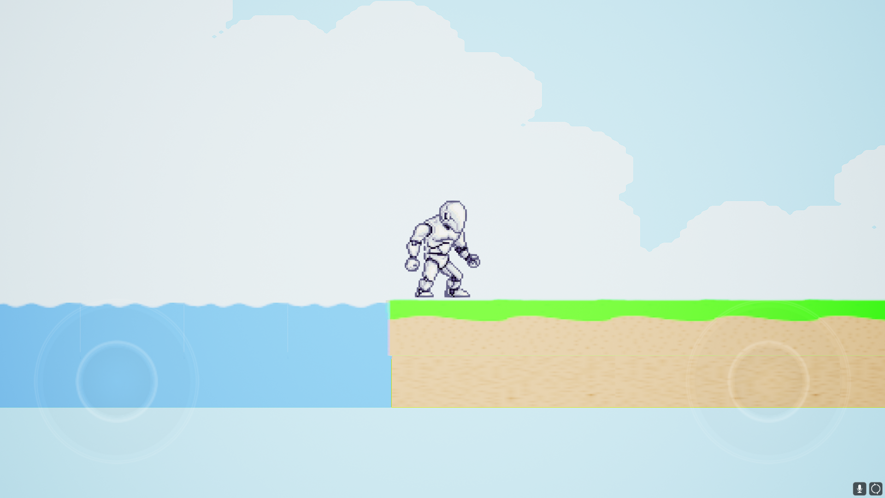

**Making of “A Broken Game”**

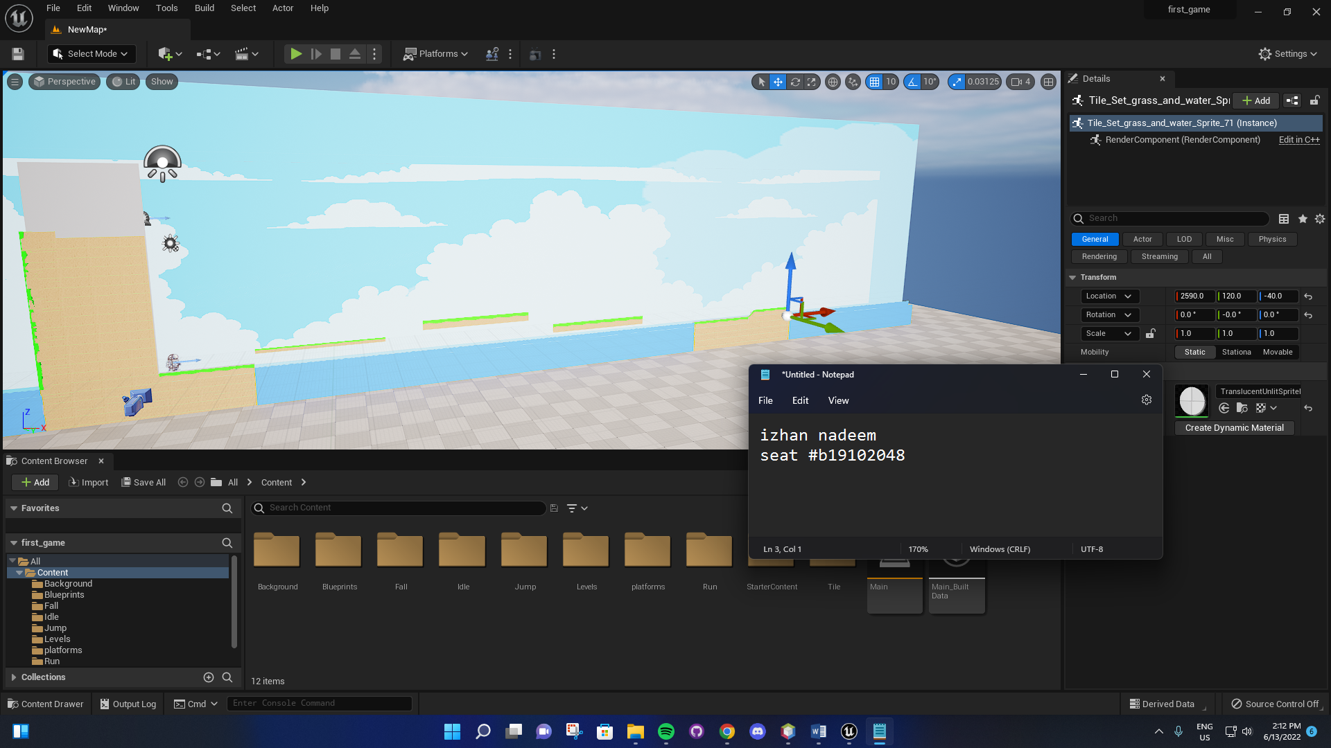

**Flipbook (Animations)**

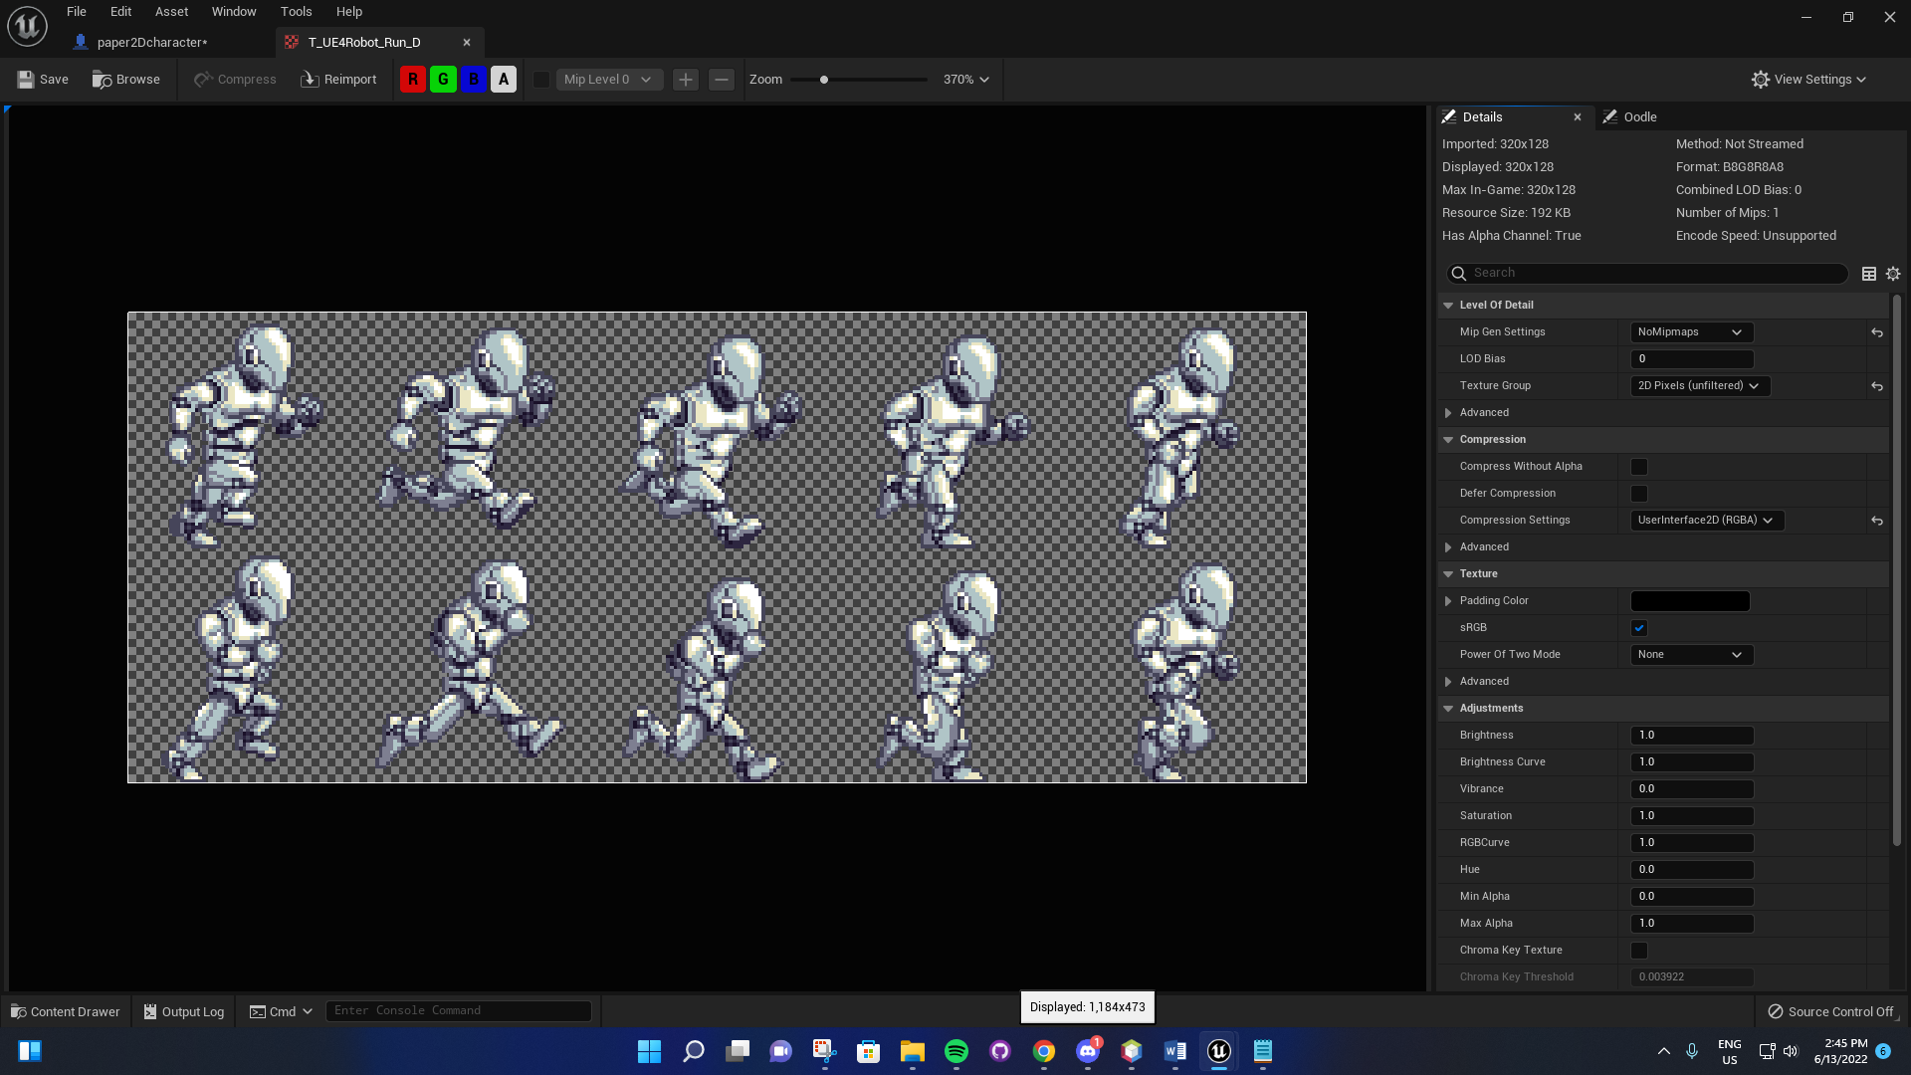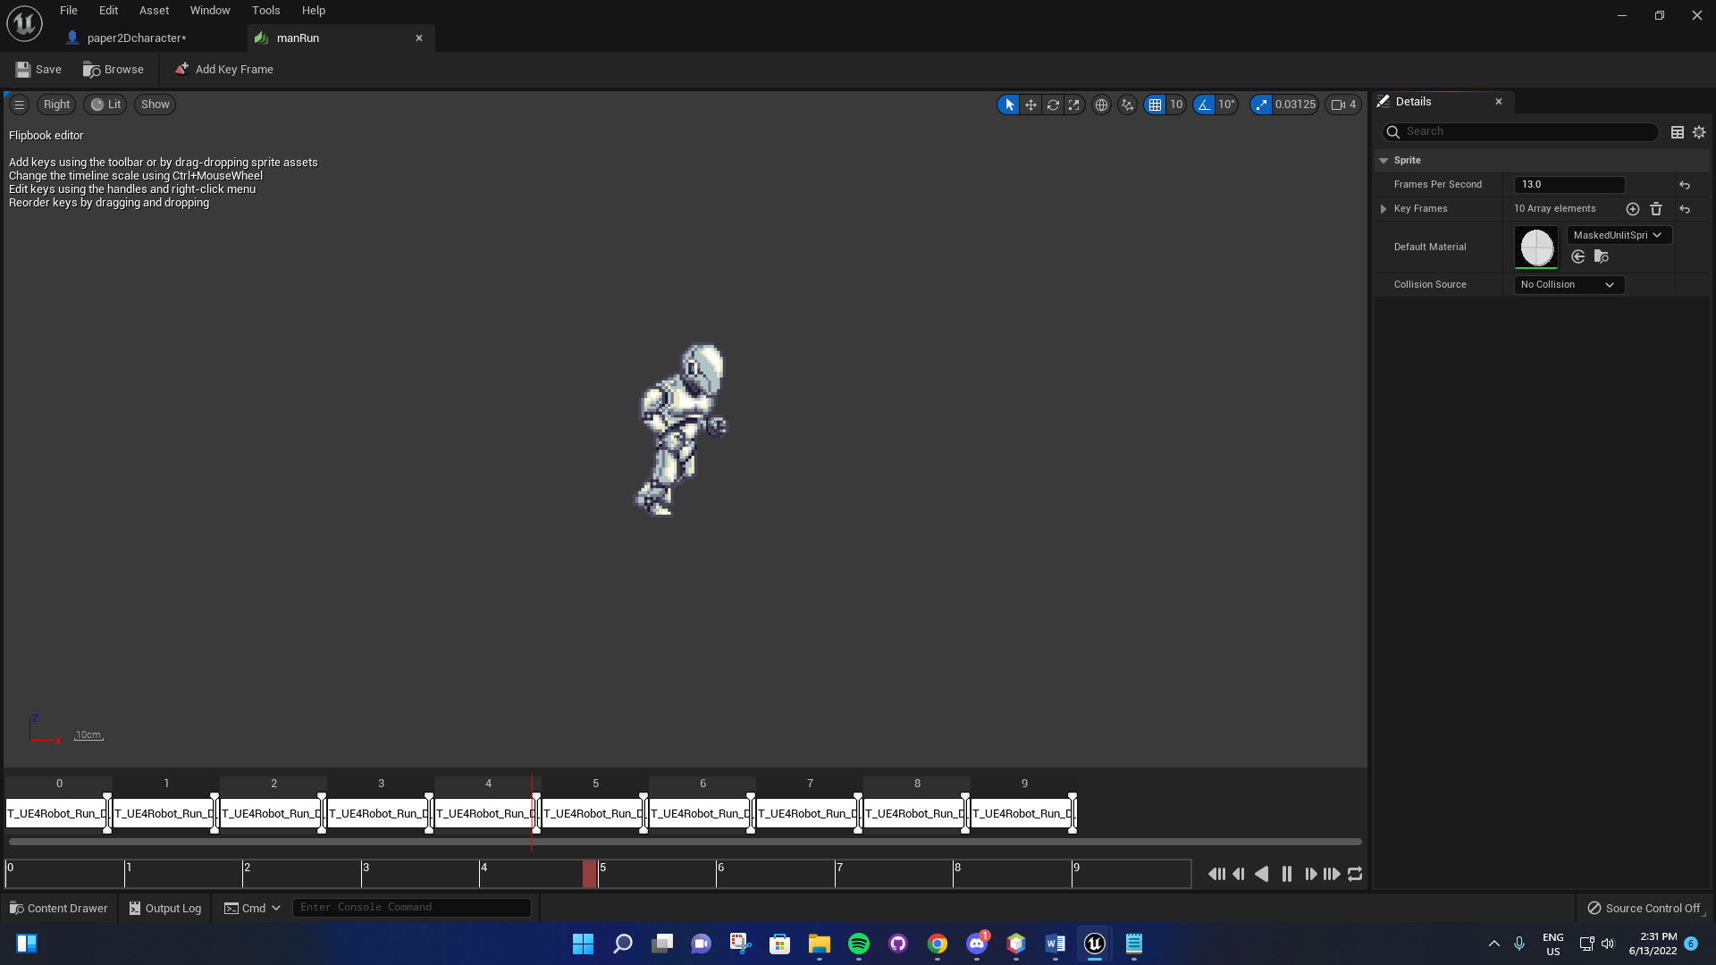

**Action Mapping**

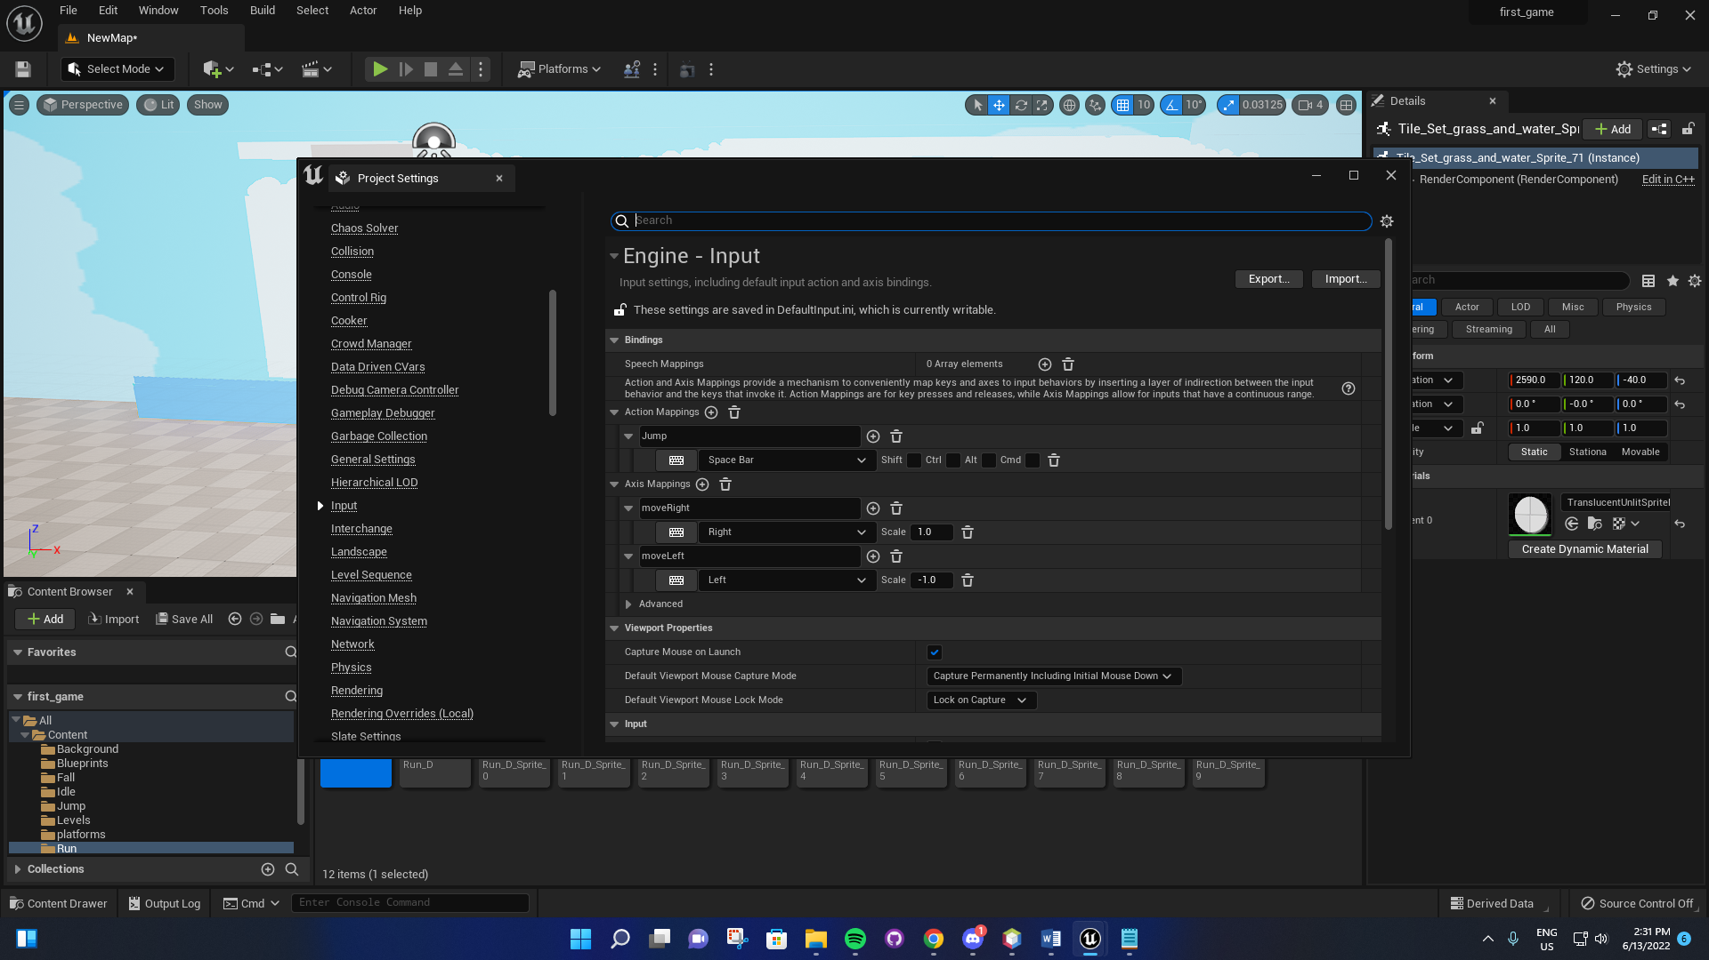

**Blueprints (DFAs)**

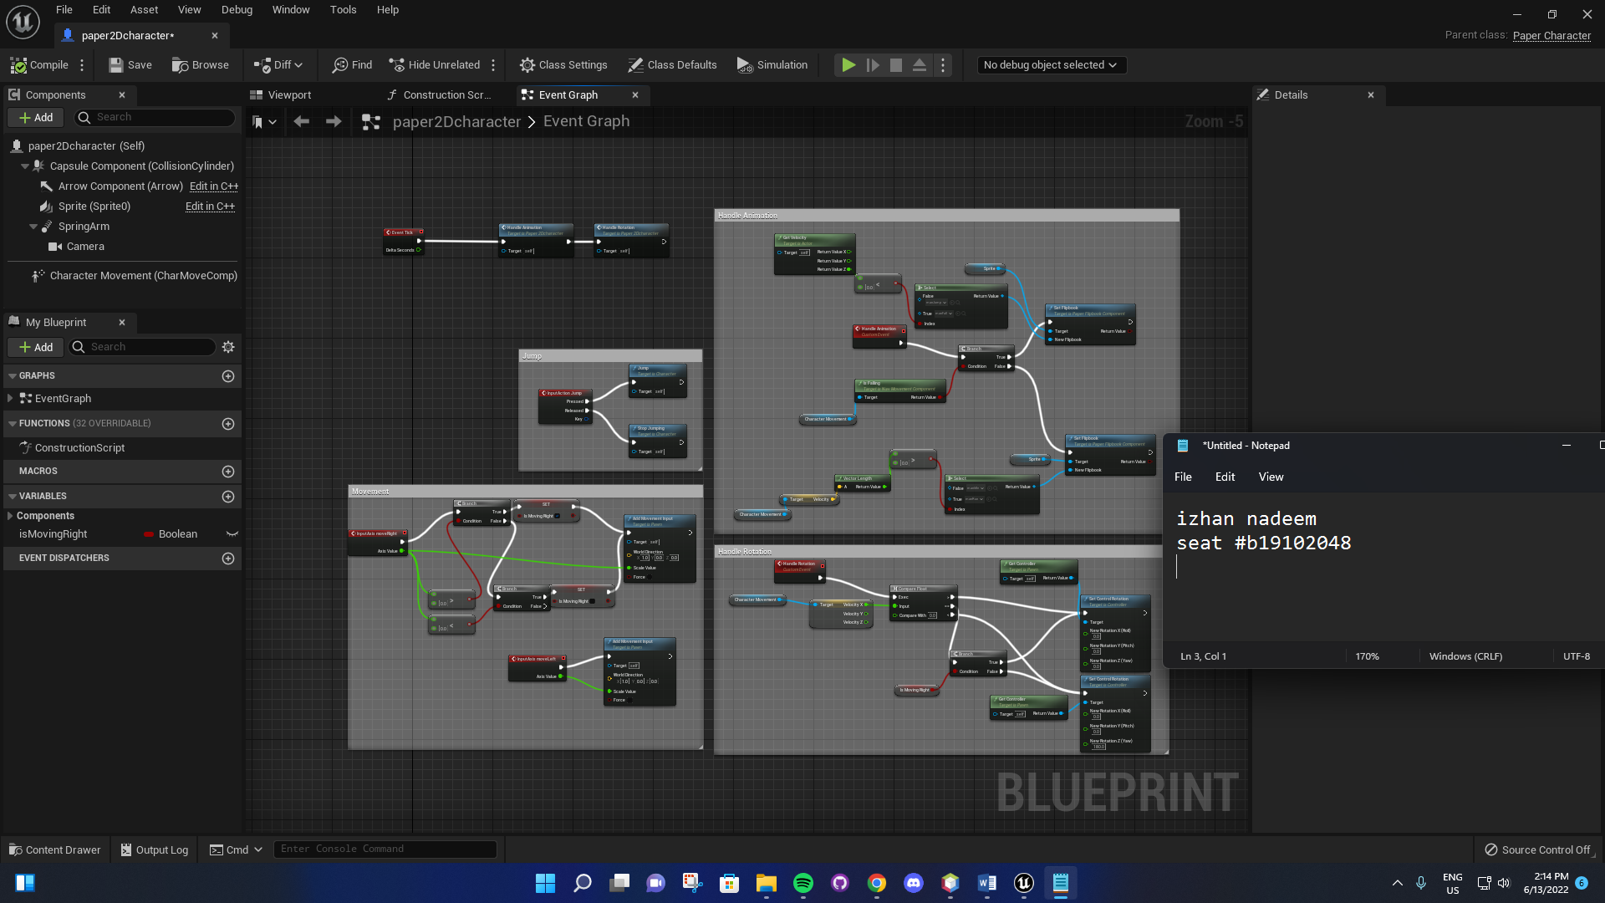

**Basic Movement**

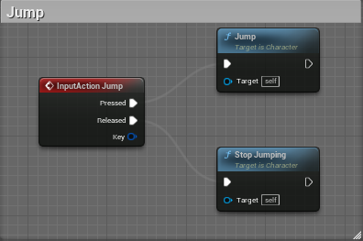

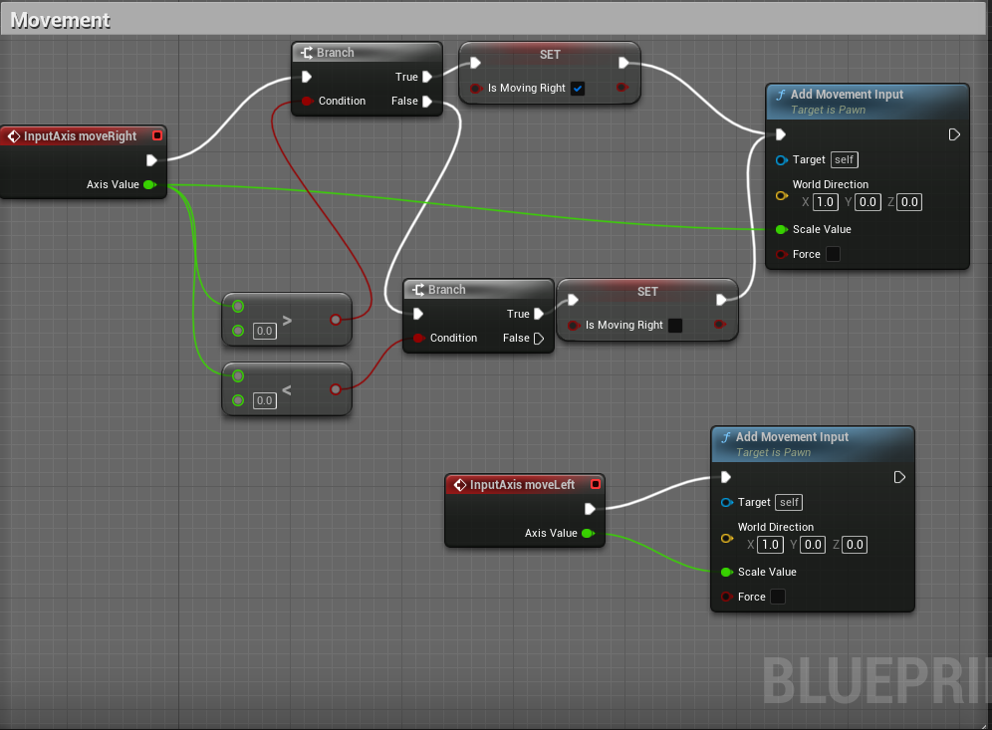

**Animation**

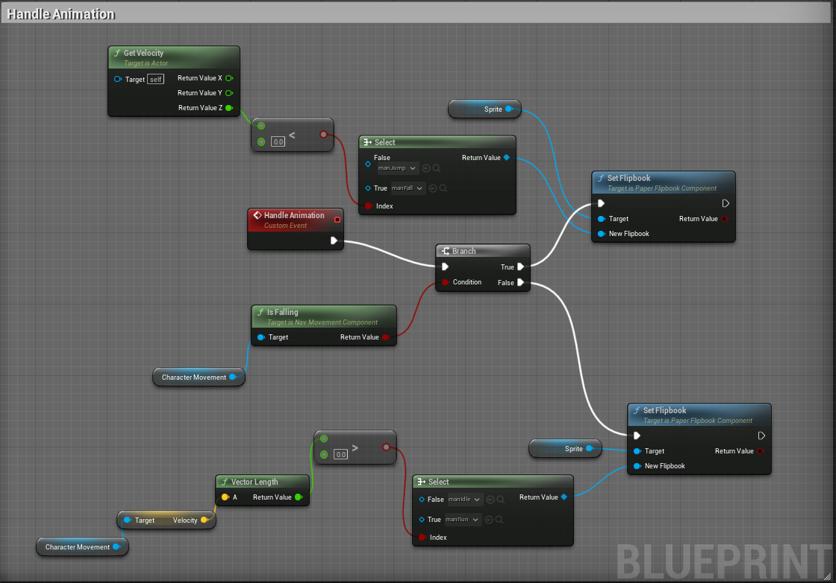

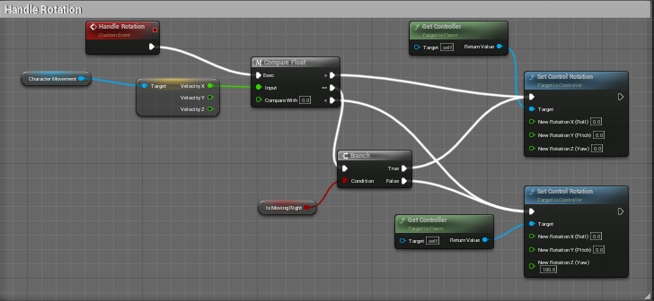

**Credits**

Game design – Izhan

Game Art – Izhan

Game Story – Izhan

Senior Developer – Izhan